EXPERIMENT 5 MARK SHEET

Step1: Create an application called ‘Mark Sheet’

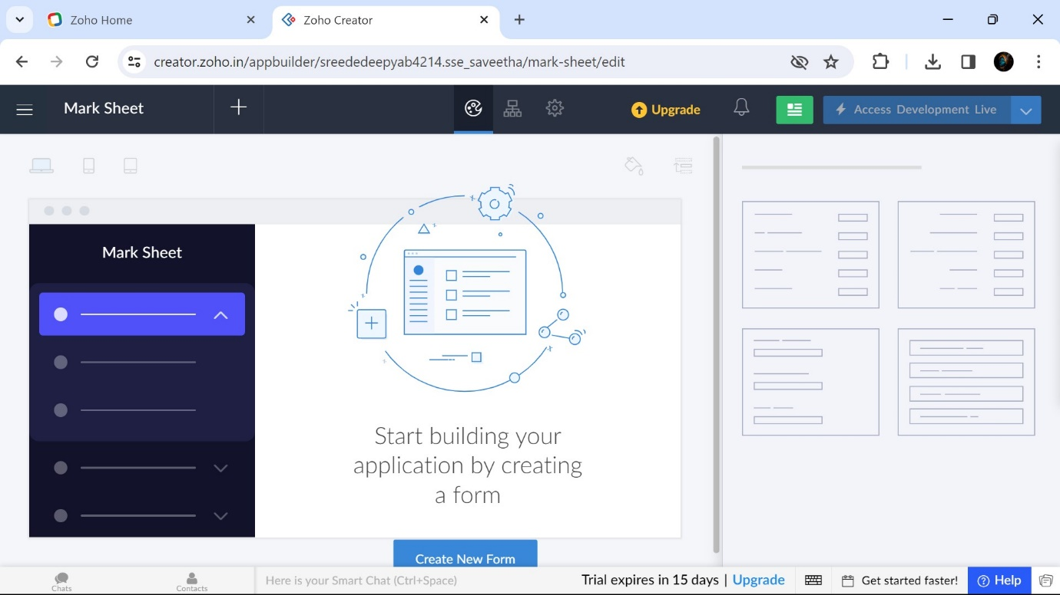

Step2: Create a form in ‘Mark Sheet’ called as Student Details

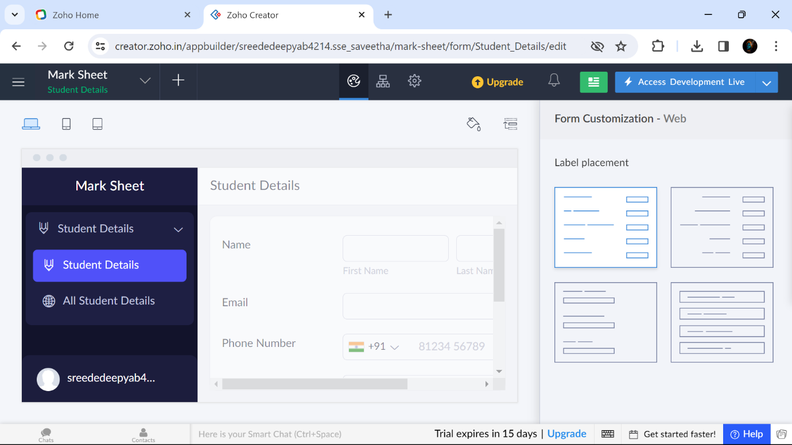

Step3: Create a form in ‘Mark Sheet’ called as Student Mark Details

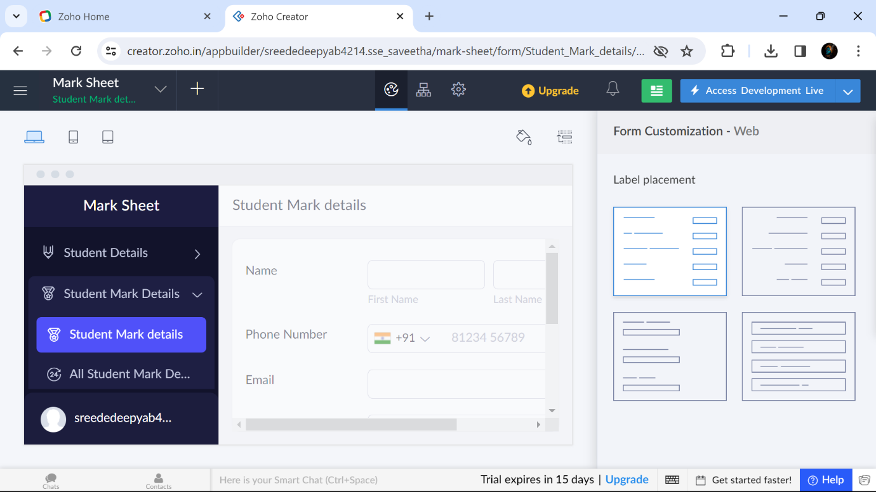

Step5:These are the details which are uploaded in the form called’ student Details’

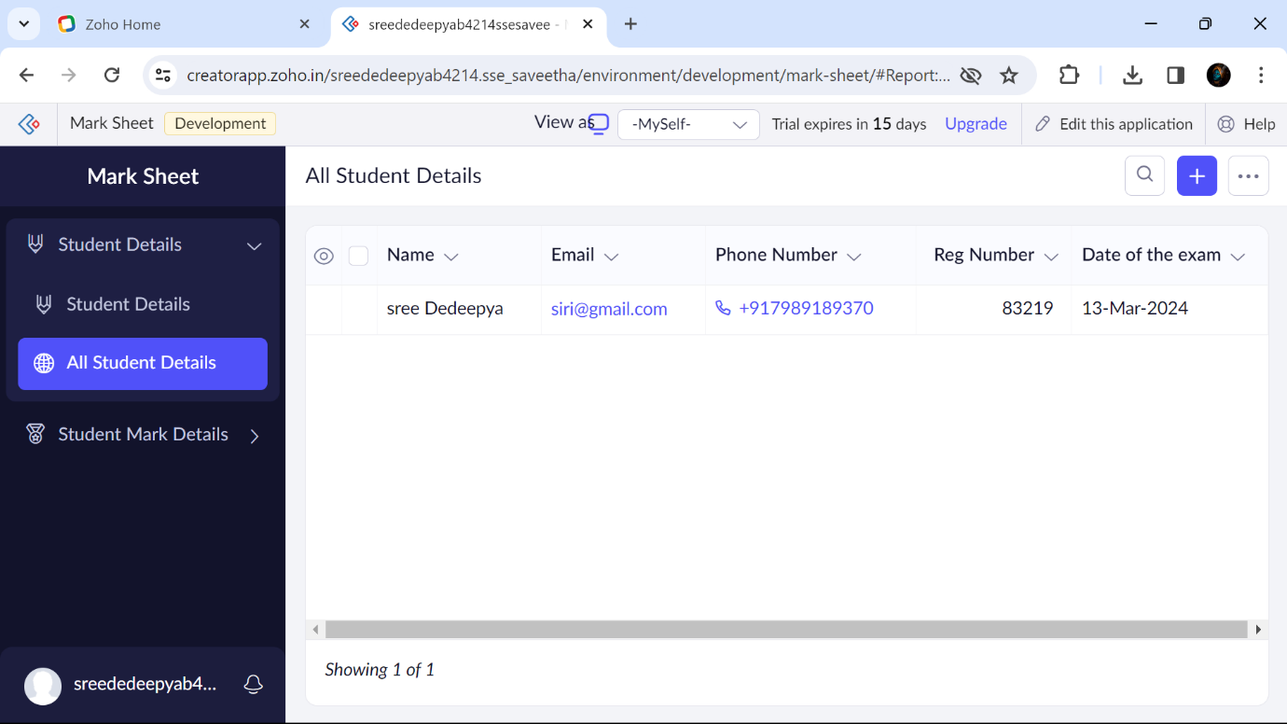

Step6 :These are the details which are uploaded in the form called’ student Mark Details’

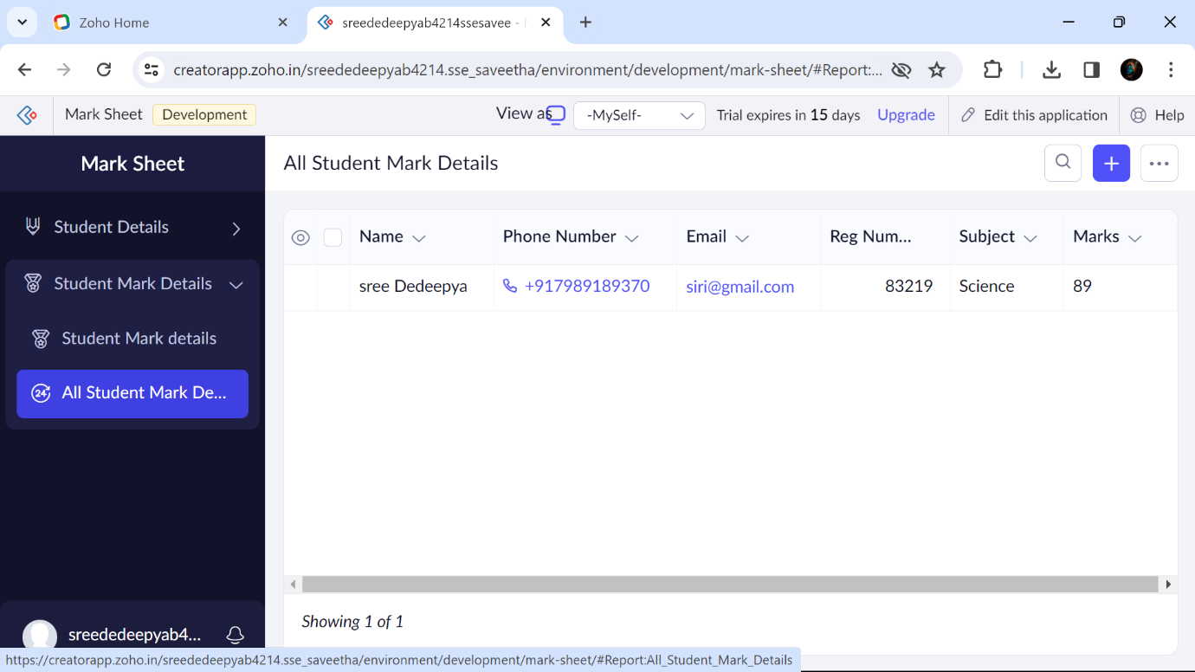

B.SREE DEDEEPYA 192224214